Weekly Wake-Up



Newsletter Date:
October 14, 2026

Club Duties
If you are unable to fulfill your duty,
PLEASE FIND A REPLACEMENT,
then let the meeting chair know.
Front of House:
October: Tyler Dakin

October 14, 2026
Front Door Greeters:
Scott Manson and Bonnie Murrell
Inspiration:
Alan Rinehart
Introductions:
Dave Thompson
Rotary Minute
Caitlin Lundgren
50/50
Bill Brendon
Sgt At Arms:
Theo Postulo
Meeting Notes:
Hayley Poirier

October 21, 2026
Front Door Greeters:
Wayne Peddie & Hayley Poirier
Inspiration:
Duane Seibel
Introductions
Tunde Adegbola
Rotary Minute
Tina Moreira
50/50:
Bill Brendon
Sgt At Arms:
Valri Cunningham
Meeting Notes:
Scott Manson

October 28, 2026
Front Door Greeters:
Theo Postulo & Kelly Raine
Inspiration:
Rick Stirling
Introductions
Donna Allen
Rotary Minute
San Mahara
50/50:
Tanya Forbes
Sgt At Arms:
Scott Manson
Meeting Notes:
Hayley Poirier

Volume 31, Issue 14

Upcoming Programs
October 14, 2026 – DG Linda Kaye Briggs – District Governor for District 5020
October 21, 2026 – Committee Reports
October 28, 2026 – Judy Cook – Advanced Care Planning When You Can’t Speak for Yourself
O 11. Janice Krall - Nanaimo Prosperity r 11. Janice Krall - Nanaimo Prosperity Corp (Pending)

Thanks to the work party at Karis House. We had 30 volunteers remove over 2000 pounds of yard waste! This photo is some of the morning crew.

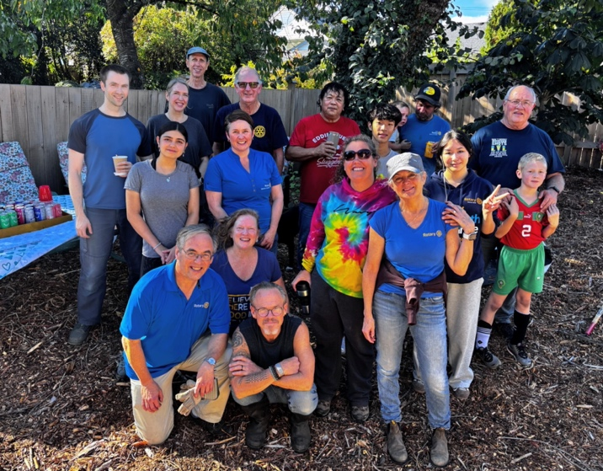

Please send content and photos for the Weekly Wake-up to kellyraine@me.com

Daybreak Donations

September 2026

Nanaimo Ladysmith School Foundation: $1000
Nanaimo and District Men’s Shed - $800
Nanaimo Child Development Centre - $2500
Canadian Cancer Society - $350

YTD Donations: $15,221.00

Club Member’s Birthdays

October 15 Mike Garvie
October 17 Sheila Klassen

Club Member’s Anniversaries

October 18 Rick & Marilu Stirling

Link to Daybreak Calendar…daybreakrotary.ca/events/
Sunshine Committee reminder... A reminder...If any members know of another member who is ill or who has had a death in the family, please let our Sunshine Committee, Donna or Valri know, so that they can send out a card on behalf of the club. Thank you.

P.O. Box 37051, #38 - 3200 Island Highway, Nanaimo, BC Canada, V9T 6N4 / Phone 250-741-9333
Rotary District 5020 / Club # 31160


October 07 meeting – Notes by Scott Manson, no photos from the meeting
~~~~~~~
Four Way Test
1. Is it the TRUTH?
2. Is it FAIR to all concerned?
3. Will it build GOODWILL and BETTER FRIENDSHIPS?
4. Will it be BENEFICIAL to all concerned?

Rotary Contacts

Club President:
Rob Mawdsley
Past President:
Sheila Klassen
Vice President:
Doug Ozeroff
Club Secretary:
Bonnie Murrell
Club Treasurer:
Anna Jones
Club President Elect:
To be elected in Dec.
Club Services Director:
Denise Davidson
Fundraising & Funds Allocation Director:
Tanya Forbes
International Services Director:
Valri Cunningham
Member Services Director:
Karin Mattern
Public Relations & Community Services Director:
Jill Mont
Youth Services Director:
Graham Calder
Directors at Large:
Doug Lum
Duane Seibel
Bulletin Editor:
Kelly Raine
Program Chair:
Rod Mont
Assistant Governor Area 4:
Jodie Williams
District Governor 2025-2026:
Linda Kaye Briggs
RI President 2026-2027:
Olayinka Babalola

Volume 31, Issue 14
Page 2
Rotary Contacts
Club President:
Anna Jones
Past President:
Doug Lum
Vice President:
Rod Mont
Club Secretary:
Sheila Forrest
Club Treasurer:
Terry Rogers
Club President Elect:
Janice Krall

International Service Director:
Tyler Vaughan
Community Service Director:
Jodi Rogers
Youth Service Director:
Bill Hardy
Club Service Director:
Sher Holubowich
Member Service Director:
Ev Boegh

Bulletin Editor:
Robb Mowbray

Assistant Governor Area 4:
Wayne Anderson
District Governor 2020-2021:
Greg Horn
RI President 2020-2021:
Holger Knaack

Make-ups
To ensure that your make-up information is properly recorded, send any info on extra meetings attended, extra committee work, service projects, online work, etc. to Denise Davidson.

~~~~~~~
Four Way Test
1. Is it the TRUTH?
2. Is it FAIR to all concerned?
3. Will it build GOODWILL and BETTER FRIENDSHIPS?
4. Will it be BENEFICIAL to all concerned?
Rotary Club Meetings
Monday – Parksville, Bayside Inn, Noon
1st, 2nd, 3rd Tuesday – Nanaimo North, Nanaimo Golf Club, 6:10 pm
Wednesday – Nanaimo Oceanside, Nanaimo Golf Club 5 p.m.
Thursday – Lantzville – ABC Restaurant on Mary Ellen Drive, 7 a.m.
Friday – Nanaimo – Coast Bastion Inn, 12:15 p.m.

President Rob clanged the bell to officially start the meeting. Rod M. lead us in O Canada on his tenor sax.

Rob R. provided our Inspiration with a quote attributed to Winston Churchill. The take away message is “while making a living is important, don’t forget to make a life.”

Abbie B. did Introductions: Ev introduced two students, Johanna from Austria, and Sean from Taiwan. Darryl introduced his friend Derrick. Rod introduced Greg, our Guest Speaker. Don H. as our Sargent at Arms used “The Longest Serving Rotarians of our Club” to determine the order of tables for breakfast.

President Rob had some announcements as we dined. Terry G. advised that he cannot be the President starting July 1st. Jill Mont has offered to step into that role! There will be an election of the 2027/28 in December. The Karis House project was a huge success with over 2000 pounds of yard waste being removed. Rob then read the Thank You note from Karis House. Our Club committed over 80 man hours to this cause!

Don’t forget - NEXT WEEK’S MEETING IS A BREAKFAST MEETING!!! The District Governor will be attending this meeting. Jodi reminded us to sign up for breakfast by SUNDAY NIGHT please! Val and Kris are overseeing the auction items for Hamperville and have asked us all to bring Silent Auction items and wine (NO CRAP!) for the Wine-barrow. Rod M. had distributed flyers for his Band’s concert “Milestones” at St. Paul’s Anglican Church, 100 Chapel Street, on Saturday, October 24, 2026, at 2:30pm. Entry is by donation. This is a benefit concert held to raise funds to support St. Paul’s new electronic organ!

Rod then introduced our guest speaker, Greg Nowik, of “Bikes for Kids”. Greg was a local Mortgage Broker for 37 years. Upon retiring, he got involved with “Secret Santa” and gave out 3 bikes to kids who needed them. 3 years after that, he gave out 150 bikes to kids! Gary O’Brian of the RCMP has donated many stolen bikes that were never claimed over the years, starting with 89 the first year, and now over 1500 this year to total over 5600 bikes! Greg hosts a bike build day every Tuesday at his shop in Cedar, that was donated by the owner of the land. Bikes go to the Multicultural Society, SD68, and many other charities to help kids.

Tyler then spoke about moving to Nanaimo so his son could play baseball. He is looking for funding to send his son to baseball camp. Businesses can donate and receive their company name on banners at the baseball field. Contact Tyler for more details.

Karin M. did the Rotary Minute. She described an article from the Canadian Edition of The Rotary Magazine. She also gave us some advice about the best way to make sure you read the magazine, is to keep it in your bathroom! The article was about the Ottawa Rotary Club, who started in 1951 “Adventure in Citizenship”, where members get to tour the House of Commons, and promote the pride of being Canadian.

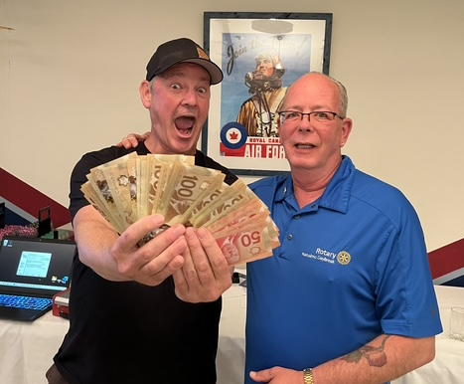
President Rob announced no birthdays or anniversaries to speak of. Dave T. drew the 50/50 ticket, and Tina won $62.50! Rob D. announced that he has shirts for sale. He is doing work with the Ladysmith Club, and a percentage of shirt sales there go to our Club!

Mike H. is doing a fundraiser selling Anducci’s Pasta Sauce. He will buy jars of sauce that we can sell and will donate the profits to our Club. Doug L. told us about the Clippers Game Friday night against Cowichan. Let’s support the team by attending the game and buying some 50/50 tickets there! Congrats to Rob D. for winning the poker tournament.

Our Sarge, Don H. fined his table for “giving him heat” about how he picked table order! Another fine meeting with the 4-Way Test at its conclusion.

