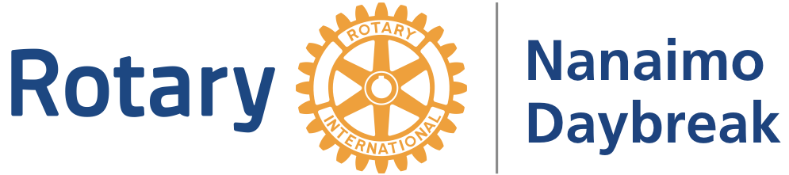

www.daybreakrotary.ca

Contact: san@drmahara.com

Participant’s Name:

Rotary Club of Nanaimo Daybreak Walk for Nepal Pledge form.
Sunday, September 24th,2023
Westwood lake, Nanaimo.
Registration opens at 9:00 am, and the Walk starts at 10 am.
____________________________________________________________________________

Goal: $ 5000

Dear friends and family,

I’m participating in the 8th annual “Rotary Walk for Nepal” happening at Westwood Lake, Nanaimo.

All the proceeds will be directly donated to the Rotary Club of Nanaimo Daybreak which funds community programs that benefit youth, school children, homelessness, disabilities, health, and seniors in Nepal.

With generous contributions from the community, our club was able to raise more than $150,000 USD so far which has helped rebuild schools and supported various projects such as

1. serving 100,000 hot meals during the Covid 19 lockdown.

2. Contribute to a “Safe drinking water project” in - 2022

3. Initiated a “Vocational Farming Programs for people with disabilities” through TRIFC, Bellevue, USA. - 2021
This year we are dedicating the funds to support a “Dental and Medical Health camp” by bringing a team of Canadian professionals in partnership with Nepalese professionals. We hope this will give a direct benefit to the local community. We’ll bring various medical and dental supplies to donate to the host clubs and the communities.

Please help me reach my personal goal by sponsoring me for any amount you are willing to contribute. You can make a check payout to “The Rotary club of Nanaimo Daybreak”. I can provide you with a contribution letter if you need one. You may donate through online at ‘daybreakrotary.ca’

Electronic payment through “Square” would be available on the walk day at the site if that works for you.

If possible, please come out and walk with me. You are welcome to bring your family, friends, and pets along.

Thank you for supporting me. Please email the organiser San Mahara at san@drmahara.com if you have any questions.

Yours in Rotary,

_________________

Name of the donor | Amount Pledged | Paid? Y/N

Name of the donor | Amount Pledged | Paid? Y/N

