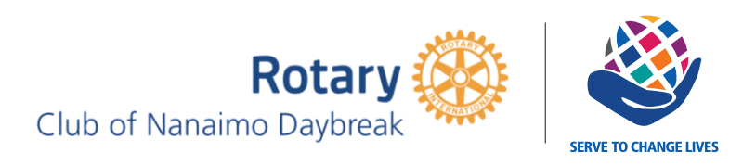

@rotarywalkfornepal @nanaimodaybreak @nepalwalk

Contact: san@drmahara.com

Participants Name:

Rotary Club of Nanaimo Daybreak Walk for Nepal Pledge form
September 25,2021
Westwood lake, Nanaimo.
Registration opens at 9:15 am Walk starts at 10 am.
____________________________________________________________________________

My personal Goal: $

Dear

I’m participating in the 6th annual “Rotary Walk for Nepal” this year happening at Westwood Lake, Nanaimo.

All the proceeds will be directly donated to the Rotary Club of Nanaimo Daybreak which funds community programs that benefit youth, school children, homeless, disabilities, health and seniors in Nepal.

With generous contributions from the community, our club was able to raise more than $100,000 USD so far which has helped rebuild schools and supported various projects such as serving 100,000 hot meals during the Covid 19 lockdown.

This year we are dedicating the funds to support “Vocational Farming Programs for people with disabilities” through TRIFC, Bellevue, USA.

Please help me reach my personal goal by sponsoring me for any amount you are willing to contribute. You can make a check payout to “The Rotary club of Nanaimo Daybreak”. I can provide you with a contribution receipt if you need one.

Electronic payment through “Square” would be available on the site as well.

If possible, please come out and walk with me. You are welcome to bring your family, friends and pets along.

Thank you for supporting me.

Yours in Rotary,

_________________

Name of the donor | Amount Pledged | Paid? Y/N

